Crea el siguiente UML (pg. 29)

Ej. 1

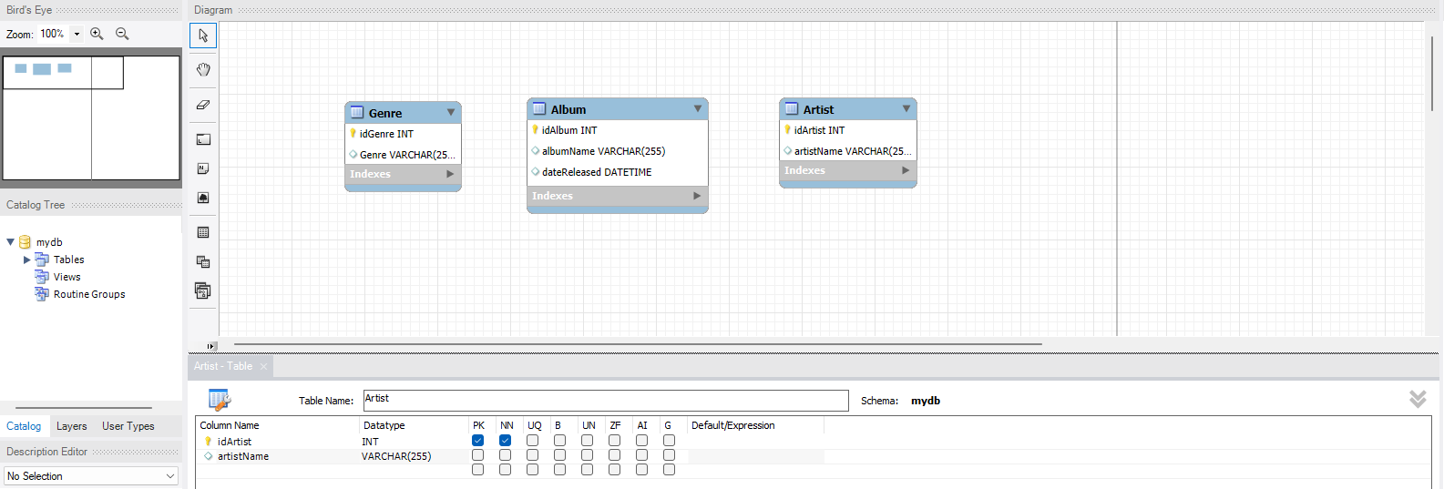

Ej. 2 (pg. 60)

Ej. 3 (pg. 66)



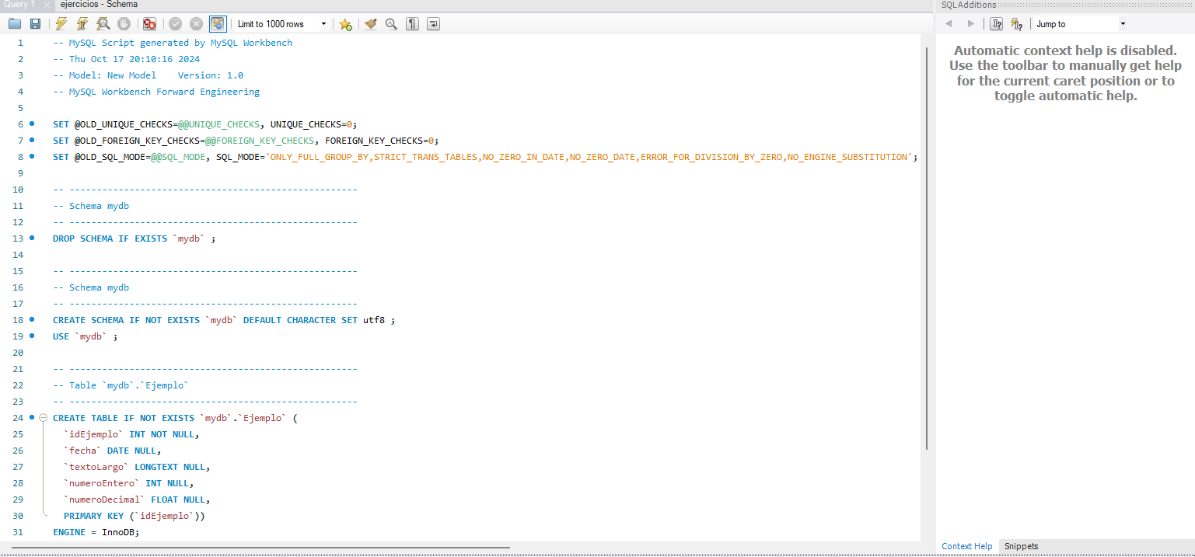
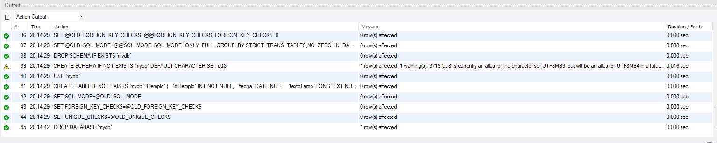

Ej. 4 (pg. 69)

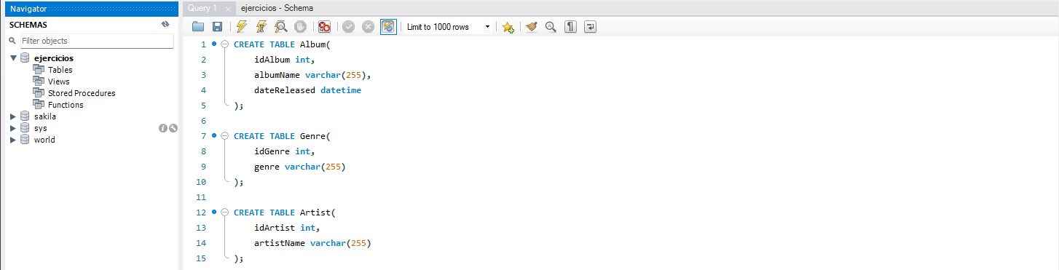

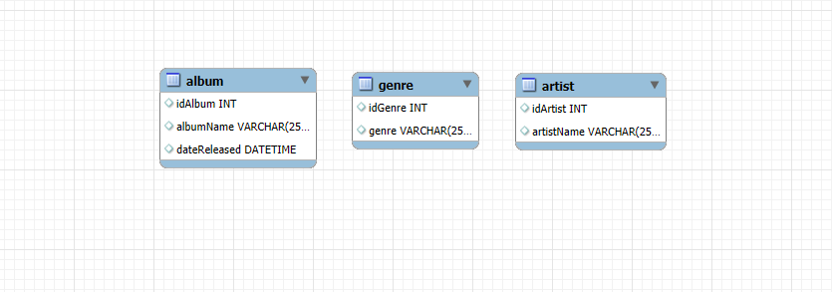

Ej. 5 (pg. 74)

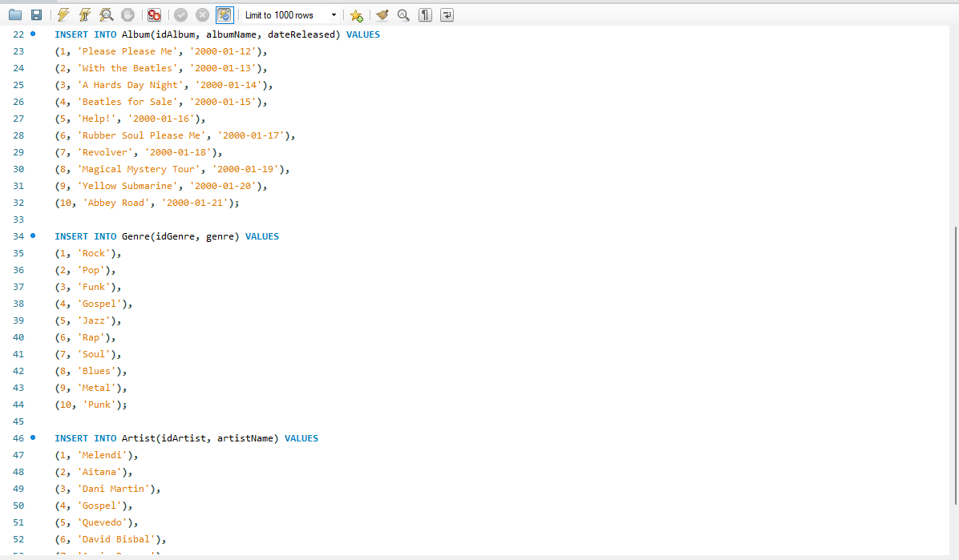
f

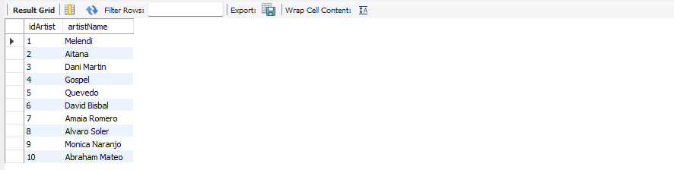

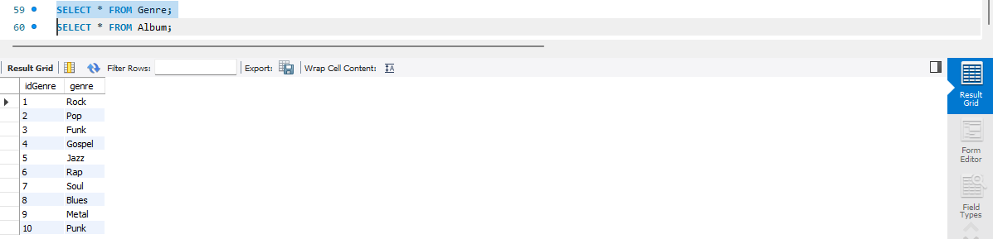

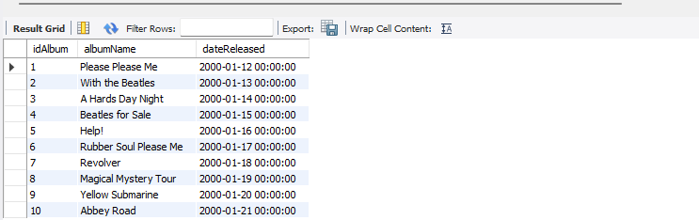

Generando datos para una BDD + Ejercicios (pg. 148)

1.
SELECT postalZip AS 'Codigo_Postal', region as 'Region', country AS 'Pais' FROM myTable;

2.
SELECT phone FROM myTable WHERE phone LIKE '(811)%';

3.
SELECT * FROM myTable WHERE country = 'Italy' or country = 'Spain';
4.
SELECT COUNT(*) FROM myTable;
5.
SELECT region, country, postalZip FROM myTable WHERE id IN (SELECT id FROM myTable WHERE country = 'Germany' or country = 'Turkey');
6.
SELECT MIN(id), MAX(id) FROM myTable;
7.
SELECT country, count(id) FROM myTable GROUP BY country;
8.
SELECT * FROM myTable ORDER BY postalZip LIMIT 10;
9.
DELETE FROM myTable WHERE country='Singapore';

10.
UPDATE myTable SET country='España' WHERE country='Spain';

Ejercicio MySQL Workbench (pg. 150)
CREATE SCHEMA IF NOT EXISTS db_geolocation;
USE db_geolocation;
DROP TABLE IF EXISTS `country`;
CREATE TABLE `country` (
`country_id` SMALLINT unsigned NOT NULL auto_increment,
`country` VARCHAR(50) default NULL,
`last_update` TIMESTAMP default NULL,
PRIMARY KEY (`country_id`)
) AUTO_INCREMENT=1;
DROP TABLE IF EXISTS `city`;
CREATE TABLE `city` (
`city_id` SMALLINT unsigned NOT NULL auto_increment,
`city` VARCHAR(50) default NULL,
`last_update` TIMESTAMP default NULL,
`country_id` SMALLINT unsigned,
PRIMARY KEY (`city_id`),
FOREIGN KEY (country_id) REFERENCES country(country_id)
) AUTO_INCREMENT=1;
DROP TABLE IF EXISTS `address`;
CREATE TABLE `address` (
`address_id` INT unsigned NOT NULL auto_increment,
`address` VARCHAR(50) default NULL,
`address2` VARCHAR(50) default NULL,
`district` VARCHAR(50) default NULL,
`postal_code` VARCHAR(10) default NULL,
`phone` VARCHAR(20) default NULL,
`location` VARCHAR(20) default NULL,
`last_update` TIMESTAMP default NULL,
`city_id` SMALLINT unsigned,
PRIMARY KEY (`address_id`),
FOREIGN KEY (city_id) REFERENCES city(city_id)
) AUTO_INCREMENT=1;
INSERT INTO country (country, last_update)
VALUES
('Espania', NOW()),
('Francia', NOW()),
('Alemania', NOW()),
('Belgica', NOW()),
('Austria', NOW()),
('Bulgaria', NOW()),
('Noruega', NOW()),
('Rep. Checa', NOW()),
('Rumania', NOW()),
('Paises Bajos', NOW()),
('Canada', NOW()),
('Japon', NOW()),
('China', NOW()),
('Mexico', NOW()),
('Peru', NOW()),
('Portugal', NOW()),
('Chile', NOW()),
('Puerto Rico', NOW()),
('Tailandia', NOW()),
('Corea', NOW());
INSERT INTO city(city, last_update, country_id)
VALUES
('Madrid', NOW(), 1),
('Barcelona', NOW(), 1),
('Berlin', NOW(), 3),
('Bruselas', NOW(), 4),
('Viena', NOW(), 5),
('Sofia', NOW(), 6),
('Oslo', NOW(), 7),
('Praga', NOW(), 8),
('Bucarest', NOW(), 9),
('Amsterdam', NOW(), 10),
('Toronto', NOW(), 11),
('Tokyo', NOW(), 12),
('Beijing', NOW(), 13),
('Ciudad de Mexico', NOW(), 14),
('Lima', NOW(), 15),
('Lisboa', NOW(), 16),
('Santiago', NOW(), 17),
('San Juan', NOW(), 18),
('Bangkok', NOW(), 19),
('Seoul', NOW(), 20);
INSERT INTO address (address, address2, district, postal_code, phone, location, last_update, city_id)
VALUES
('011 Calle de Aragón', 'Apt 1', 'stilf Bazaar', '10001', '123-456-7890', 'Location1', NOW(), 1),
('899 Calle de Alcalá de Guadaíra', 'Apt 2', 'coopab Hill', '90001', '987-654-3210', 'Location2', NOW(), 3),
('981 Calle de Avinyó', '', 'Central', 'Lower liv', '456-789-1234', 'Location3', NOW(), 3),
('199 Calle de Entenza', 'Suite 3', 'Waterside', 'V6E 1B4', '654-321-0987', 'Location4', NOW(), 4),
('911 Calle de Balmes', '', 'spramiok', '01000', '321-098-7654', 'Location5', NOW(), 5),
('972 Calle de la Jota', 'Floor 4', 'spagob', 'SW1A 1AA', '01234 567890', 'Location6', NOW(), 6),
('530 Calle de Muntaner', '', 'Lower nomd', '10115', '030 1234567', 'Location7', NOW(), 7),
('858 Calle de Pelayo', '', 'Altstadt', '80331', '089 12345678', 'Location8', NOW(), 8),
('011 Calle de Aragón', 'Apt 1', 'Uper sprem', '10001', '123-456-7890', 'Location1', NOW(), 9),
('899 Calle de Alcalá de Guadaíra', 'Apt 2', 'Lower Nor', '90001', '987-654-3210', 'Location2', NOW(), 8),
('981 Calle de Avinyó', '', 'Central', 'M5H 2N2', '456-789-1234', 'Location3', NOW(), 10),
('199 Calle de Entenza', 'Suite 3', 'West End', 'V6E 1B4', '654-321-0987', 'Location4', NOW(), 11),
('911 Calle de Balmes', '', 'Midtown proand', '01000', '321-098-7654', 'Location5', NOW(), 12),
('972 Calle de la Jota', 'Floor 4', 'Chelsea', 'SW1A 1AA', '01234 567890', 'Location6', NOW(), 13),
('530 Calle de Muntaner', '', 'Mitte', '10115', '030 1234567', 'Location7', NOW(), 14),
('858 Calle de Pelayo', '', 'Altstadt', '80331', '089 12345678', 'Location8', NOW(), 15),
('199 Calle de Entenza', 'Apt 1', 'Midtown proand', '10001', '123-456-7890', 'Location1', NOW(), 16),
('858 Calle de Pelayo', 'Apt 2', 'North sneepord', '90001', '987-654-3210', 'Location2', NOW(), 17),
('789 Maple St', '', 'stregaic Center', 'M5H 2N2', '456-789-1234', 'Location3', NOW(), 18),
('530 Calle de Muntaner', 'Suite 3', 'puriatlen Circle', 'V6E 1B4', '654-321-0987', 'Location4', NOW(), 19),
('972 Calle de la Jota', 'Suite 3', 'dossotop Row', 'V6E 1B4', '654-321-0987', 'Location4', NOW(), 20);
SELECT country, city, address, phone
FROM country AS pais
INNER JOIN
city AS ciudad
ON pais.country_id = ciudad.city_id
INNER JOIN
address AS direccion
ON ciudad.city_id = direccion.city_id;

Ejercicio MySQL Workbench (pg. 151)

CREATE SCHEMA IF NOT EXISTS db_sales_enterprise;
USE db_sales_enterprise;
DROP TABLE IF EXISTS `customer`;
CREATE TABLE `customer` (
`customer_id` SMALLINT NOT NULL auto_increment,
`cust_name` VARCHAR(30) default NULL,
`city` VARCHAR(15) default NULL,
`grade` SMALLINT default NULL,
PRIMARY KEY (`customer_id`)
) AUTO_INCREMENT=1;
DROP TABLE IF EXISTS `salesman`;
CREATE TABLE `salesman` (
`salesman_id` SMALLINT NOT NULL auto_increment,
`name` VARCHAR(30) default NULL,
`city` VARCHAR(15) default NULL,
`commission` REAL default NULL,
PRIMARY KEY (`salesman_id`)
) AUTO_INCREMENT=1;
CREATE TABLE orders (
order_number SMALLINT NOT NULL auto_increment,
purchase_amt DECIMAL(8,2) DEFAULT NULL,
order_date DATE DEFAULT NULL,
customer_id SMALLINT NOT NULL,
salesman_id SMALLINT NOT NULL,
PRIMARY KEY (order_number, customer_id, salesman_id),
FOREIGN KEY (customer_id) REFERENCES customer(customer_id),
FOREIGN KEY (salesman_id) REFERENCES salesman(salesman_id)
) AUTO_INCREMENT=1;
INSERT INTO customer (cust_name, city, grade)
VALUES ('Alex Tintor', 'Nueva York', 100),
('Aitor Menta', 'Los Angeles', 200),
('Elena Morada', 'Chicago', 150),
('Benito Camelas', 'Florida', 180),
('Deborah Dora', 'Nueva York', 220),
('John Smith', 'Grecia', 190),
('Frank Stein', 'Malibu', 210),
('Gene McGee', 'St. Petersburg', 170),
('Elmo Skito', 'Brooklyn', 160),
('Elton Tito', 'Berlin', 120);
INSERT INTO salesman (name, city, commission)
VALUES
('Alex Johnson', 'New York', 0.15),
('Jose Smith', 'Los Angeles', 0.12),
('Michael Green', 'Chicago', 0.14),
('David Brown', 'Chicago', 0.16),
('Betty White', 'Metropolis', 0.13),
('Frank Gray', 'Grecia', 0.10),
('Grace Silver', 'Malibu', 0.11),
('Harry Gold', 'St. Petersburg', 0.09),
('Ivy Diamond', 'Brooklyn', 0.08),
('Jack Daemon', 'Boston', 0.17);
INSERT INTO orders (purchase_amt, order_date, customer_id, salesman_id)
VALUES
(500.50, '2023-01-15', 1, 1),
(300.00, '2023-02-12', 2, 2),
(450.75, '2023-03-10', 3, 3),
(600.25, '2023-04-05', 4, 4),
(700.80, '2023-05-20', 5, 5),
(250.40, '2023-06-30', 6, 6),
(550.90, '2023-07-14', 7, 7),
(450.60, '2023-08-19', 8, 8),
(350.70, '2023-09-02', 9, 9),
(650.30, '2023-10-10', 10, 10);
SELECT count(order_number) FROM orders;
SELECT DISTINCT cust_name FROM customer;
SELECT * FROM salesman ORDER BY commission DESC;
SELECT * FROM customer ORDER BY customer_id ASC LIMIT 5;
SELECT MIN(purchase_amt) FROM orders;
SELECT MAX(purchase_amt) FROM orders;

Ejercicio MySQL Workbench (pg. 151)

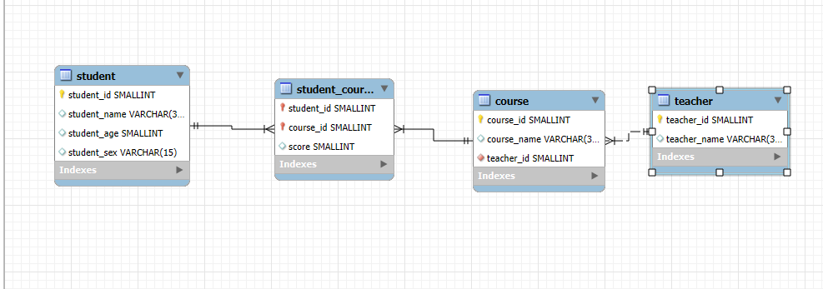

CREATE SCHEMA IF NOT EXISTS db_school;
USE db_school;
DROP TABLE IF EXISTS student;
CREATE TABLE student (
student_id SMALLINT NOT NULL auto_increment,
student_name VARCHAR(35) default NULL,
student_age SMALLINT default NULL,
student_sex VARCHAR(15) default NULL,
PRIMARY KEY (student_id)
) AUTO_INCREMENT=1;
DROP TABLE IF EXISTS teacher;
CREATE TABLE teacher (
teacher_id SMALLINT NOT NULL auto_increment,
teacher_name VARCHAR(35) default NULL,
PRIMARY KEY (teacher_id)
) AUTO_INCREMENT=1;
DROP TABLE IF EXISTS course;
CREATE TABLE course (
course_id SMALLINT NOT NULL auto_increment,
course_name VARCHAR(35) default NULL,
teacher_id SMALLINT NOT NULL,
PRIMARY KEY (course_id),
FOREIGN KEY (teacher_id) REFERENCES teacher(teacher_id)
) AUTO_INCREMENT=1;
DROP TABLE IF EXISTS student_course;
CREATE TABLE student_course (
student_id SMALLINT NOT NULL,
course_id SMALLINT NOT NULL,
score SMALLINT default NULL,
PRIMARY KEY (student_id, course_id),
FOREIGN KEY (student_id) REFERENCES student(student_id),
FOREIGN KEY (course_id) REFERENCES course(course_id)
);

Ejercicio MySQL Workbench (pg. 152)

CREATE SCHEMA IF NOT EXISTS db_school;
USE db_school;
DROP TABLE IF EXISTS student;
CREATE TABLE student (
student_id SMALLINT NOT NULL auto_increment,
student_name VARCHAR(35) default NULL,
student_age SMALLINT default NULL,
student_sex VARCHAR(15) default NULL,
PRIMARY KEY (student_id)
) AUTO_INCREMENT=1;
DROP TABLE IF EXISTS teacher;
CREATE TABLE teacher (
teacher_id SMALLINT NOT NULL auto_increment,
teacher_name VARCHAR(35) default NULL,
PRIMARY KEY (teacher_id)
) AUTO_INCREMENT=1;
DROP TABLE IF EXISTS course;
CREATE TABLE course (
course_id SMALLINT NOT NULL auto_increment,
course_name VARCHAR(35) default NULL,
teacher_id SMALLINT NOT NULL,
PRIMARY KEY (course_id),
FOREIGN KEY (teacher_id) REFERENCES teacher(teacher_id)
) AUTO_INCREMENT=1;
DROP TABLE IF EXISTS student_course;
CREATE TABLE student_course (
student_id SMALLINT NOT NULL,
course_id SMALLINT NOT NULL,
score SMALLINT default NULL,
PRIMARY KEY (student_id, course_id),
FOREIGN KEY (student_id) REFERENCES student(student_id),
FOREIGN KEY (course_id) REFERENCES course(course_id)
);
INSERT INTO student (student_name, student_age, student_sex)
VALUES
('Aitor Menta', 20, 'Hombre'),
('Benito Camelas', 22, 'Hombre'),
('Deborah Dora', 19, 'Mujer'),
('Alicia Llaves', 21, 'Mujer'),
('Cristina Flores', 23, 'Hombre'),
('Alberto Abierto', 18, 'Mujer'),
('Victor Buenamigo', 24, 'Hombre'),
('Laura Dora', 22, 'Mujer'),
('Mike Thompson', 21, 'Hombre'),
('Chris Jackson', 20, 'Hombre');
INSERT INTO teacher (teacher_name)
VALUES
('Emmet Brown'),
('Rick Sanchez'),
('James Neutron'),
('Flink Stein'),
('Albert Einstein'),
('Bethany White'),
('Mekane Orange'),
('Sophia Violet'),
('George Washing'),
('Billy Jackson');
INSERT INTO course (course_name, teacher_id)
VALUES
('Matematicas', 1),
('Biologia', 2),
('Quimica', 3),
('Historia', 4),
('Fisica', 5),
('Filosofia', 6),
('Ingles', 7),
('Latin', 8),
('Frances', 9),
('Aleman', 10);
INSERT INTO student_course (student_id, course_id, score)
VALUES
(1, 1, 85),
(1, 2, 90),
(2, 3, 75),
(2, 4, 80),
(3, 1, 95),
(3, 5, 88),
(4, 2, 78),
(4, 6, 82),
(5, 3, 90),
(5, 7, 85),
(6, 4, 91),
(6, 8, 77),
(7, 1, 88),
(7, 9, 92),
(8, 2, 81),
(8, 10, 79),
(9, 3, 84),
(9, 5, 87),
(10, 4, 86),
(10, 6, 89);
SELECT stu.student_name, tea.teacher_name FROM student stu
LEFT JOIN student_course stu_cour ON stu.student_id = stu_cour.student_id
LEFT JOIN course cour ON stu_cour.course_id = cour.course_id
LEFT JOIN teacher tea ON tea.teacher_id = cour.teacher_id;
SELECT tea.teacher_name, COUNT(cour.course_id) FROM course cour
LEFT JOIN teacher tea ON tea.teacher_id = cour.teacher_id GROUP BY cour.teacher_id;
SELECT stu.student_name, COUNT(stuco.course_id) FROM student_course stuco
LEFT JOIN student stu ON stuco.student_id = stu.student_id GROUP BY stuco.student_id;

Ejercicio MySQL Workbench (pg. 152)

ROLLBACK

Para este ejercicio se realizarán las actividades en la tabla students creada para la actividad anterior:

SELECT * from students;

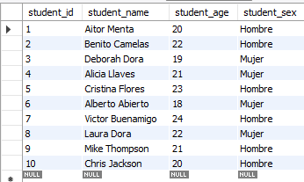

Begin;
DELETE FROM student_course WHERE student_id IN (SELECT student_id FROM student);
DELETE FROM student;
SELECT * from student;
Rollback;

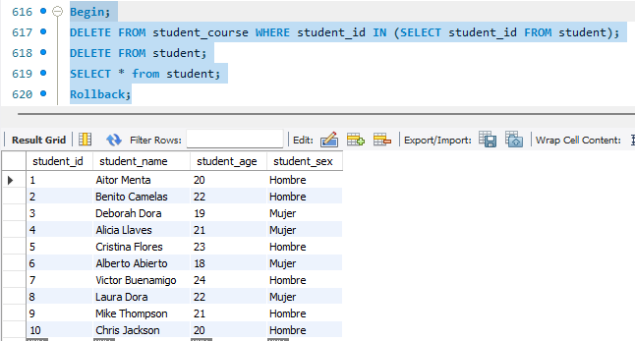

COMMIT

Begin;
DELETE FROM student_course WHERE student_id IN (SELECT student_id FROM student);
DELETE FROM student;
SELECT * from student;
Commit;

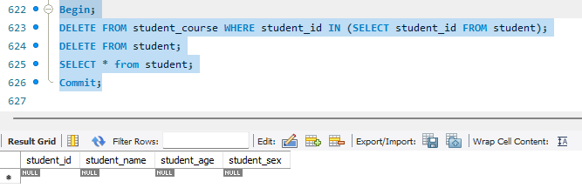

Ejercicio 1. creación de tablas y relaciones entre tablas (PDF)

1.

DROP DATABASE IF EXISTS cinema_db;
CREATE DATABASE IF NOT EXISTS cinema_db;
USE cinema_db;
CREATE TABLE IF NOT EXISTS movies(
id int NOT NULL AUTO_INCREMENT,
title varchar(100) UNIQUE,
year int UNIQUE,
image_url varchar(255) UNIQUE,
certificate varchar(45),
runtime int,
imdb_ranting float,
description TEXT,
metascore int,
votes int,
gross int,
PRIMARY KEY (id)
);
CREATE TABLE IF NOT EXISTS directors(
id int NOT NULL AUTO_INCREMENT,
name varchar(45) UNIQUE,
about TEXT,
PRIMARY KEY (id)
);
CREATE TABLE IF NOT EXISTS stars(
id int NOT NULL AUTO_INCREMENT,
name varchar(45) UNIQUE,
about TEXT,
PRIMARY KEY (id)
);
CREATE TABLE IF NOT EXISTS genres(
id int NOT NULL AUTO_INCREMENT,
name varchar(45) UNIQUE,
PRIMARY KEY (id)
);
CREATE TABLE IF NOT EXISTS movie_directors(
movies_id int,
directors_id int,
PRIMARY KEY (movies_id, directors_id),
FOREIGN KEY (movies_id)
REFERENCES cinema_db.movies(id),
FOREIGN KEY (directors_id)
REFERENCES cinema_db.directors(id)
);
CREATE TABLE IF NOT EXISTS movie_stars(
movies_id int,
stars_id int,
PRIMARY KEY (movies_id, stars_id),
FOREIGN KEY (movies_id)
REFERENCES cinema_db.movies(id),
FOREIGN KEY (stars_id)
REFERENCES cinema_db.stars(id)
);
CREATE TABLE IF NOT EXISTS movie_genres(
movies_id int,
genres_id int,
PRIMARY KEY (movies_id, genres_id),
FOREIGN KEY (movies_id)
REFERENCES cinema_db.movies(id),
FOREIGN KEY (genres_id)
REFERENCES cinema_db.genres(id)
);

2.

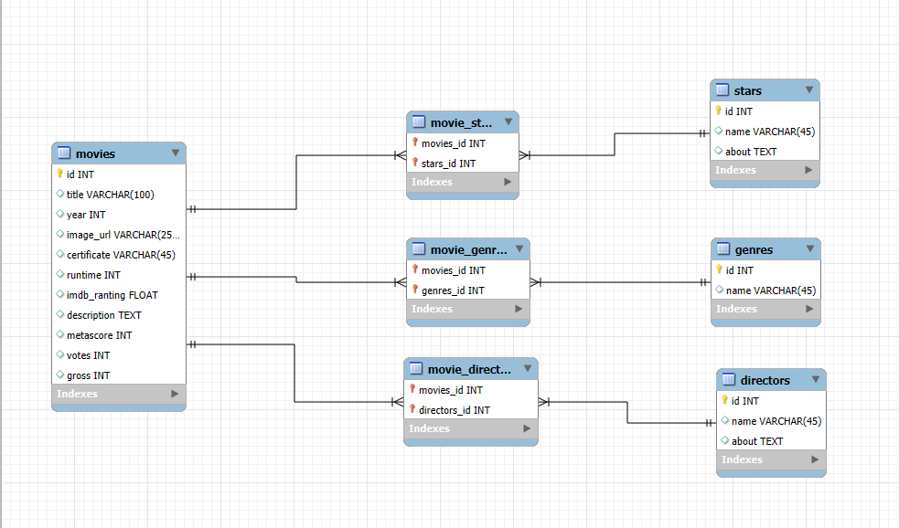
El esquema E/R coincide con el modelo propuesto en el ejercicio.

3.

INSERT INTO movies (title, year, image_url, certificate, runtime, imdb_ranting, description, metascore, votes, gross)
VALUES ('Back to the future', 1985, 'https://www.imdb.com/title/tt0088763/mediaviewer/rm3415438592/?ref_=tt_ov_i', 'PG', 116, 8.5,
'Marty McFly, a 17-year-old high school student, is accidentally sent 30 years into the past in a time-traveling DeLorean invented by his close friend, the maverick scientist Doc Brown.',
87, 999, 384577472),
('The Empire Strikes Back', 1980, 'https://www.imdb.com/title/tt0080684/mediaviewer/rm2002357760/?ref_=tt_ov_i', 'PG', 124, 8.7,
'After the Rebels are brutally overpowered by the Empire on the ice planet Hoth, Luke Skywalker begins Jedi training with Yoda, while his friends are pursued by Darth Vader.', 82, 1170000, 538375067),
('A New Hope', 1977, 'https://www.imdb.com/title/tt0076759/mediaviewer/rm3126483456/?ref_=tt_ov_i', 'PG', 121, 8.6,
'Luke Skywalker joins forces with a Jedi Knight, a cocky pilot, a Wookiee, and two droids to save the galaxy from the Empire\'s world-destroying battle station while also attempting to rescue Princess Leia from the mysterious Darth Vader.', 90, 1300000, 775398007),
('Revenge of the Sith', 2005, 'https://www.imdb.com/title/tt0121766/mediaviewer/rm1940222464/?ref_=tt_ov_i', 'PG-13', 140, 7.6,
'Three years into the Clone Wars, the Jedi rescue Palpatine from Count Dooku. As Obi-Wan pursues a new threat, Anakin acts as a double agent between the Jedi Council and Palpatine and is lured into a sinister plan to rule the galaxy.', 68, 750000, 848998877),
('The Lord of the Rings: The Two Towers', 2002, 'https://www.imdb.com/title/tt0167261/mediaviewer/rm3592950272/?ref_=tt_ov_i', 'PG-13', 179, 8.8,
'While Frodo and Sam edge closer to Mordor with the help of the shifty Gollum, the divided fellowship makes a stand against Sauron\'s new ally, Saruman, and his hordes of Isengard.', 87, 1600000, 947000000),
('How to Train Your Dragon', 2010, 'https://www.imdb.com/title/tt0892769/mediaviewer/rm1396368384/?ref_=tt_ov_i', 'PG', 98, 8.1,
'A hapless young Viking who aspires to hunt dragons becomes the unlikely friend of a young dragon himself, and learns there may be more to the creatures than he assumed.', 75, 720000, 494878759),
('Shrek 2', 2004, 'https://www.imdb.com/title/tt0298148/mediaviewer/rm1959573504/?ref_=tt_ov_i', 'PG', 93, 7.3,
'Shrek and Fiona travel to the Kingdom of Far Far Away, where Fiona\'s parents are King and Queen, to celebrate their marriage. When they arrive, they find they are not as welcome as they thought they would be.', 75, 680000, 928760770),
('Toy Story 3', 2010, 'https://www.imdb.com/title/tt0435761/mediaviewer/rm3892618240/?ref_=tt_ov_i', 'G', 103, 8.3,
'The toys are mistakenly delivered to a day-care center instead of the attic right before Andy leaves for college, and it\'s up to Woody to convince the other toys that they weren\'t abandoned and to return home.', 92, 890000, 1066969703),
('Ratatouille', 2007, 'https://www.imdb.com/title/tt0382932/mediaviewer/rm1186899712/?ref_=tt_ov_i', 'G', 111, 8.1,
'A rat who can cook makes an unusual alliance with a young kitchen worker at a famous restaurant.', 96, 690000, 620702951),
('The Wizard of Oz', 1939, 'https://www.imdb.com/title/tt0032138/mediaviewer/rm3477868800/?ref_=tt_ov_i', 'G', 102, 8.1,
'Dorothy Gale is swept away from a farm in Kansas to a magical land of Oz in a tornado and embarks on a quest with her new friends to see the Wizard who can help her return home.', 92, 380000, 239000000),
('Jurassic Park', 1993, 'https://www.imdb.com/title/tt0107290/mediaviewer/rm552303360/?ref_=tt_ov_i', 'PG-13', 127, 8.1,
'A pragmatic paleontologist visiting an almost complete theme park is tasked with protecting a couple of kids after a power failure causes the park\'s cloned dinosaurs to run loose.', 68, 920000, 1040290000);
INSERT INTO directors (name, about)
VALUES ('Robert Zemeckis', ' director, productor y guionista estadounidense de cine. En 1984, alcanzó popularidad con su primera película destacada, Romancing the Stone, donde se narra una aventura de una pareja por Colombia.'),
('George Lucas', ' Es un cineasta estadounidense. Lucas es principalmente conocido por crear las franquicias de Star Wars e Indiana Jones y fundar Lucasfilm, LucasArts e Industrial Light & Magic. Cesó como presidente de Lucasfilm antes de venderlo a The Walt Disney Company en 2012.'),
('Peter Jackson', 'Es un director, guionista y productor de cine neozelandés, conocido especialmente por dirigir, producir y coescribir1​ la trilogía cinematográfica de El Señor de los Anillos.'),
('Brad Bird', 'Es un director de animación, guionista y director de cine estadounidense. Ha dirigido, entre otras, Ratatouille, Los Increíbles y El gigante de hierro.'),
('Steven Spielberg', 'Es un director, guionista y productor de cine estadounidense.1​ Se le considera uno de los pioneros de la era del Nuevo Hollywood y es también uno de los directores más reconocidos y populares de la industria cinematográfica mundial.'),
('Lee Unkrich', 'Es un director de cine y montador estadounidense.'),
('Chris Sanders', 'Es un cineasta, animador y actor de voz estadounidense.'),
('Victor Flemming', 'Fue un director de cine, director de fotografía y productor estadounidense.');
INSERT INTO genres (name)
VALUES ('Ciencia ficcion'),
('Comedia'),
('Familiar'),
('Fantasia'),
('Aventuras'),
('Accion'),
('Animacion'),
('Infantil'),
('Catastrofe'),
('Drama');
INSERT INTO stars (name, about)
VALUES ('Christopher Lloyd', 'Es un actor estadounidense. Ha interpretado a Doc Emmett Brown en la trilogía de Back to the Future.'),
('Harrison Ford', 'Es un actor, productor, y actor de voz estadounidense de cine y televisión. Es recordado por haber interpretado al personaje de Indiana Jones, y también a Han Solo en la saga de Star Wars'),
('Mark Hamill', 'Es un actor de cine, televisión, voz, director, productor y escritor estadounidense. Es conocido por interpretar a Luke Skywalker en la serie de películas Star Wars.'),
('Ewan McGregor', 'Es un actor, cantante y director de cine británico nacionalizado estadounidense. Es famoso sobre todo por haber protagonizado la película de culto británica Trainspotting (1996).'),
('Elijah Wood', 'Es un actor de cine y televisión estadounidense. Debutó con un papel menor en Back to the Future Part II (1989), y después consiguió una serie de papeles cada vez más relevantes.'),
('Jay Baruchel', 'Es un actor, director, guionista y productor canadiense. Comenzó su carrera tempranamente, a mediados de la década de 1990, en programas de televisión de su país. Después de eso, trabajó en producciones estadounidenses tales como Casi famosos (2000).'),
('Michael John Myers', 'Es un actor, comediante, guionista, productor y director canadiense.1​ Ha actuado en Saturday Night Live (1988-1995), Waynes World, en las tres películas de Austin Powers y ha prestado su voz en la serie de películas de Shrek.'),
('Tom Hanks', 's un actor, guionista, productor de cine y director de cine estadounidense.2​ Es de los intérpretes más reconocidos de Hollywood. Varias de sus películas, sean dramas o comedias, han recibido el reconocimiento internacional.'),
('Patton Oswald', 'es un actor, humorista de comedia en vivo (stand-up) y guionista estadounidense. Es más conocido por sus papeles como Spencer Olchin en The King of Queens, por haber sido la voz de Remy en la película Ratatouille'),
('Judy Garland', 'Fue una actriz y cantante estadounidense. Si bien fue aclamada por la crítica por muchos papeles diferentes a lo largo de su carrera, es ampliamente conocida por interpretar el papel de Dorothy Gale en The Wizard of Oz (1939).'),
('Sam Neil','Es un actor neozelandés nacido en Reino Unido. Conocido por su papel de Damien Thorn en Omen III: The Final Conflict (La profecía III) y de Alan Grant en Parque Jurásico.');
SELECT * from movies;
INSERT INTO movie_directors (movies_id, directors_id)
VALUES(1,1),
(2,2),
(3,2),
(4,2),
(5,3),
(6,7),
(7,6),
(8,4),
(9,4),
(10,8),
(11,5);
INSERT INTO movie_stars (movies_id, stars_id)
VALUES(1,1),
(2,2),
(3,3),
(4,4),
(5,5),
(6,6),
(7,7),
(8,8),
(9,9),
(10,10),
(11,11);
INSERT INTO movie_genres (movies_id, genres_id)
VALUES(1,1),
(1,2),
(1,6),
(2,1),
(2,4),
(2,6),
(2,10),
(3,4),
(3,6),
(3,10),
(4,4),
(4,6),
(4,10),
(5,4),
(5,5),
(5,6),
(6,2),
(6,3),
(6,4),
(7,2),
(7,3),
(7,8),
(8,2),
(8,3),
(8,8),
(9,2),
(9,3),
(9,8),
(10,3),
(10,4),
(10,8),
(11,3),
(11,9),
(11,10);

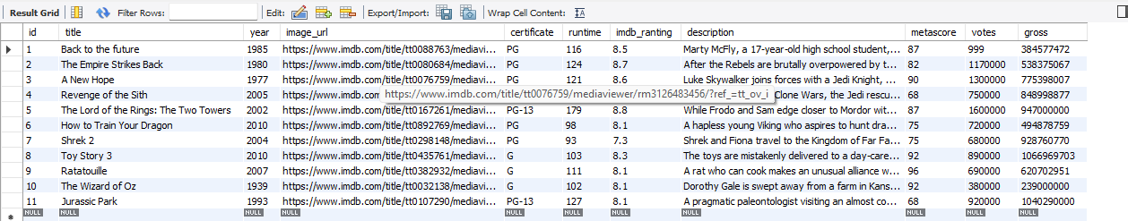

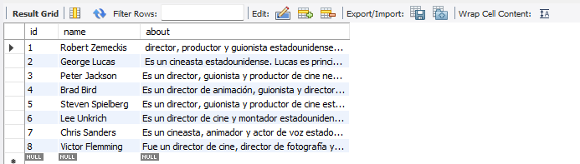

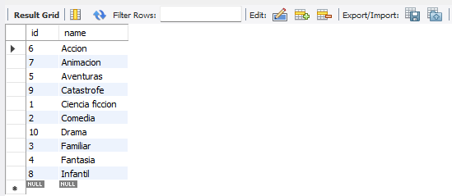

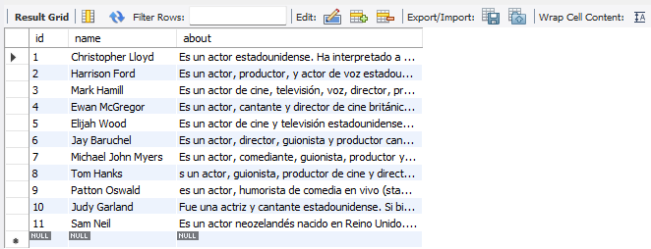

4.

CREATE TABLE IF NOT EXISTS movie_directors(
movies_id int,
directors_id int,
PRIMARY KEY (movies_id, directors_id),
FOREIGN KEY (movies_id)
REFERENCES cinema_db.movies(id)
ON DELETE CASCADE,
FOREIGN KEY (directors_id)
REFERENCES cinema_db.directors(id)
ON DELETE CASCADE
);
CREATE TABLE IF NOT EXISTS movie_stars(
movies_id int,
stars_id int,
PRIMARY KEY (movies_id, stars_id),
FOREIGN KEY (movies_id)
REFERENCES cinema_db.movies(id)
ON DELETE CASCADE,
FOREIGN KEY (stars_id)
REFERENCES cinema_db.stars(id)
ON DELETE CASCADE
);
CREATE TABLE IF NOT EXISTS movie_genres(
movies_id int,
genres_id int,
PRIMARY KEY (movies_id, genres_id),
FOREIGN KEY (movies_id)
REFERENCES cinema_db.movies(id)
ON DELETE CASCADE,
FOREIGN KEY (genres_id)
REFERENCES cinema_db.genres(id)
ON DELETE CASCADE
);
-------------------------------------------------------

DELETE FROM movies;
DELETE FROM stars;
DELETE FROM directors;
DELETE FROM genres;

